Sandeepan Datta Final Project

A Financial Services which provides financial research, recommendation, advice, products and a collective information from other popular financial website

●Sandeepan Datta

●CSCI S-12

●Harvard Summer School, Summer 2020

Table of Contents:

Strategy

Scope

Structure

# Strategy

1. Name of the site: **“aVcon iNternational**”

2. Purpose and goals of the site:

* The purpose of the website is to provide financial services to retail as well as institutional customers. The site will provide customized research data to customers who want to use standardized tools to compare companies across different geographies and different accounting standards.
* This website will deliver standardized research reports to clients for investment purposes (also known as soft dollars). It will also offer various financial products which a user can use for their investment decisions.
* The website will also be a unified platform which will give collective financial data from popular financial websites like yahoo finance, Bloomberg, Morningstar etc.

3. Audiences

* Primary audience: The primary audience will be retails investors (individual customers) and institutional clients (banks, pension funds, portfolio funds) globally. The site is expected to act as a single source of information about financial data, financial products and research. The research and recommendations will solely be based on historic data and may vary with future market conditions. The recommendations should not be treated as legal advice.
* Secondary audience: People with no knowledge of the financial markets. New investors, students can get a lot of information about the financial markets by reading different reports and financial data available in the website.

# Scope

Ideas for content/function for site:

● Companies covered:

○ Apple, Google, Microsoft, Facebook, IBM

● For each of the 5 companies we will capture:

○ Sales

○ Margins

○ Net Profit

● Interactive (JavaScript) ideas

○ Charts showing how the sales/margins look for each company and across companies for last 3 years

○ Map that shows the corporate headquarters for each company

● Resources: Yahoo Finance. Bloomberg, Morningstar.

* For Charts I plan to use D3.js or charts.js,
* For Maps I plan to use Google API/Leaflet
* Pixabay and other sites with images covered under creative commons.

# Structure

The website will have a main home page with a carousel and a navigation bar.

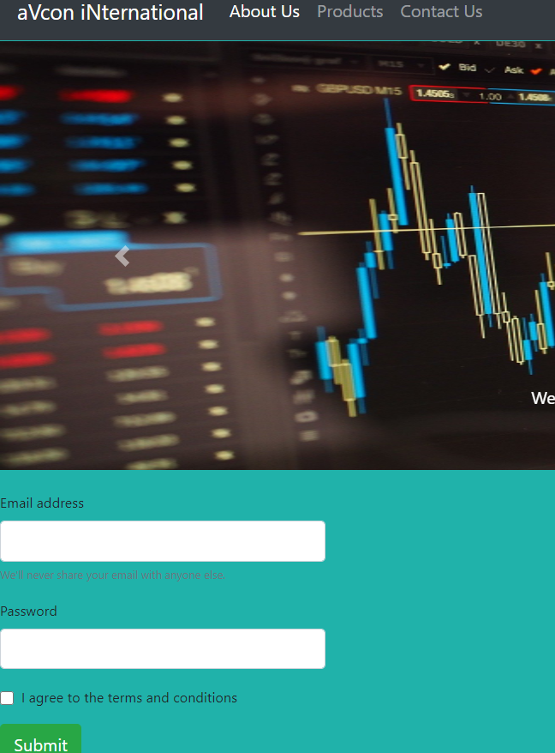

It will have all the pages linked via the navigation bar.

The About Us Page will give a brief description of the company and its founder (me)

The Products will give the Financial Data and Charts for the companies highlighted above. It will also include the JavaScript functionality (interactive chart and maps)

The contact us page will have details regarding a customer contact form.